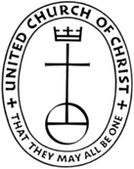
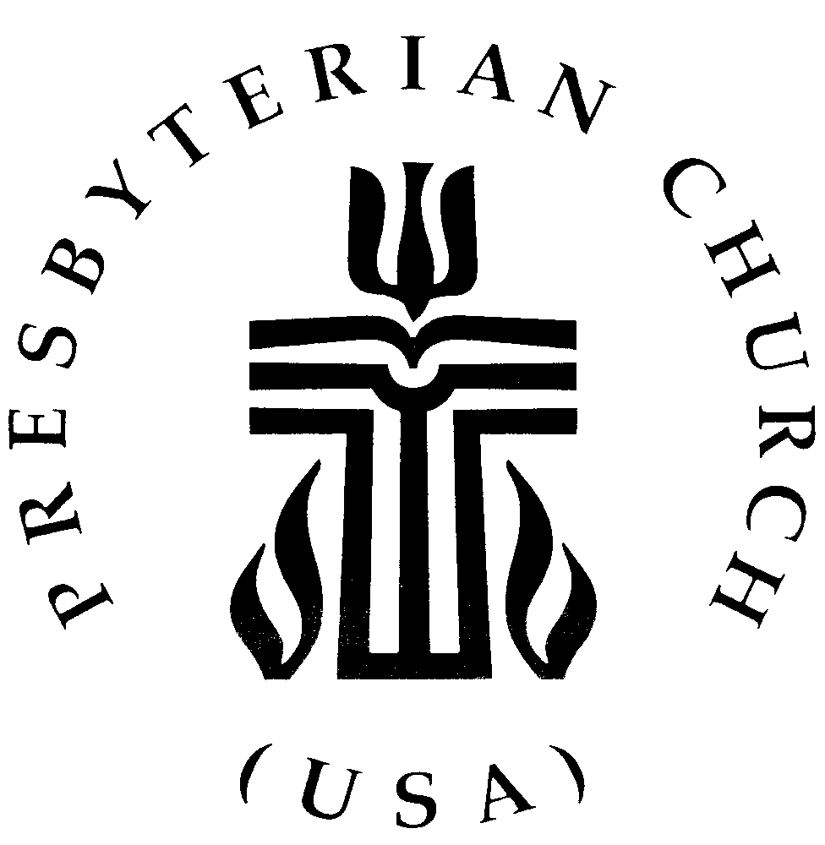
THE FEDERATED CHURCH
224 N. Union Avenue, Fergus Falls, Minnesota 56537 Phone: (218)739-3227
Pastor Douglas Dent
AUTHORIZATION AGREEMENT FOR DIRECT PAYMENTS (ACH DEBITS)
Company Name: The Federated Church

I (we) hereby authorize the Federated Church to initiate debit entries to my (our) Checking Account or Savings Account indicated below at Security State Bank, Fergus Falls, MN, and to debit such account. I (we) acknowledge that the origination of ACH transactions to my (our) account must comply with the provisions of the U.S. Law.

Depositor: Security State Bank,
City: Fergus Falls, State: MN Zip code: 56537

Checking Account
Bank Routing Number ___________________________ Account Number _________________________

This authorization is to remain in full force and effect until The Federated Church has received written notification from me (or either of us) of its termination in such a time and such manner as to afford The Federated Church and Security State Bank a reasonable opportunity to act on it.

Printed Name: ____________________________________________________
Signature: _____________________________________________________

Joint Owner (if applicable) Printed Name: __________________________________________
Signature: __________________________________________
ACH debit to first occur month of _________________, _____
Regular debit(s) made on (choose) _____ 2nd _____16th of each month by in the amount of : $_________.

Please attach a voided check (not a deposit slip) to this form and return to the church office.

