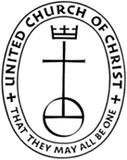
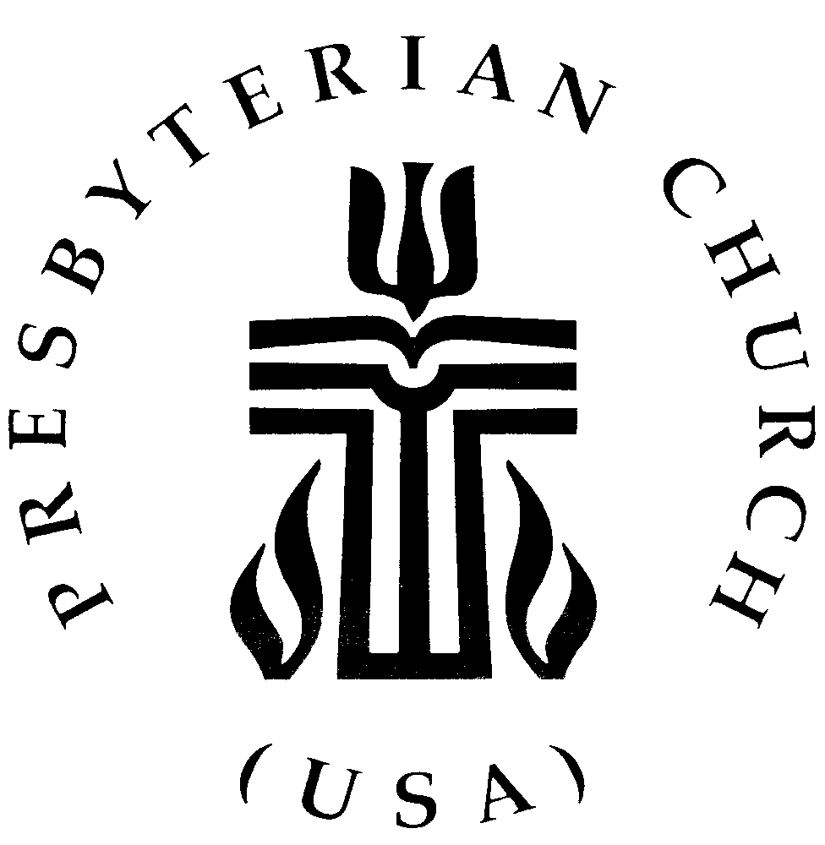
THE FEDERATED CHURCH
224 N. Union Avenue, Fergus Falls, Minnesota 56537

(218)739-3227  church@federatedff.org

Reverend Douglas Dent, Pastor

Application for Employment

Name (First) (Middle) (Last)

Address

Email Driver’s License Number Religious Affiliation

Home Phone Cell Phone Date available to begin
Employment type you prefer: _____ Part-Time _____ Full-Time _____ Either

*Please submit a résumé noting your educational background, employment history, wage history, computer skills/other qualifications, and at least three references we may contact.

I understand that this is an application for a position only and does not imply any promises of employment on behalf of the Federated Church.

I understand that employment is subject to a favorable report from the MN Bureau of Criminal Apprehension.

I hereby declare that all of the information on this Employment Application Form (and any other documentation submitted as part of the application process) is accurate and true; and I understand that any falsehood or omission on my part may be grounds for future dismissal from the position or withdrawal of an offer of employment.

SIGNATURE Date

