**Vacation Bible School**

**June 27-July 1, 2022**

**9:00 am to 12 noon**

**Registration Form**

**Parents Name(s)**

**Address**

**Phone Cell**

**Work Phone Email**

**Emergency Contact**

**Address Phone**

**Children Age Grade Allergies**

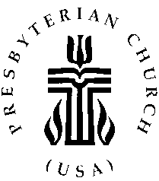

The Federated Church

224 North Union Ave.

Fergus Falls, MN 56537

218.739.3227

[www.federatedff.org](http://www.federatedff.org)

email: church@federatedff.org