Hear, O people of God: the LORD our God, the LORD is one. You shall have no other gods before him. Exodus 15:11, 18

What do we believe about God the Father? **We believe in God, the Father Almighty.**

Who among the gods is like you, LORD? Who is like you — majestic in holiness, awesome in glory, working wonders? . . . The LORD reigns forever and ever. Exodus 15:11

**We believe in God, the creator of heaven and earth.**

By the word of the LORD the heavens were made, their starry host by the breath of his mouth. He gathers the waters of the sea into jars; he puts the deep into storehouses. Let all the earth fear the LORD; let all the people of the world revere him. For he spoke, and it came to be; he commanded, and it stood firm. Psalm 33:6-9

**Hymn #645** Sing Praise to God Who Reigns Above

**God the Son**

What do we believe about God the Son? **We believe in Jesus Christ, his only Son, our Lord.**

The Son is the radiance of God’s glory and the exact representation of his being, sustaining all things by his powerful word. After he had provided purification for sins, he sat down at the right hand of the Majesty in heaven. Hebrews 1:3

**He was conceived by the Holy Spirit and born of the virgin Mary. He suffered under Pontius Pilate, was crucified, died, and was buried; he descended to hell.**

“Who, being in very nature God, did not consider equality with God something to be used to his own advantage; rather, he made himself nothing by taking the very nature of a servant, being made in human likeness. And being found in appearance as a man, he humbled himself by becoming obedient to death — even death on a cross!” He bore our grief and carried our sorrows and delivered us from the anguish and torment of hell. Philippians 2:6-8

**The third day he rose again from the dead. He ascended to heaven and is seated at the right hand of God the Father almighty. From there he will come to judge the living and the dead.**

“Therefore, God exalted him to the highest place and gave him the name that is above every name, that at the name of Jesus every knee should bow, in heaven and on earth and under the earth, and every tongue acknowledge that Jesus Christ is Lord, to the glory of God the Father.” Philippians 2:9-11

**Praise Song** *In Christ Alone*

**God the Holy Spirit**

What do we believe about God the Holy Spirit? **We believe in the Holy Spirit.**

“When the Spirit of truth, comes, he will guide you into all the truth. The Spirit will not speak on his own; the Spirit will speak only what the Spirit hears, and the Spirit will tell you what is yet to come. The Spirit will glorify me because it is from me that the Spirit will receive what the Spirit will make known to you.” John 16:13–14

Because you are God’s sons and daughters, God sent the Spirit of God’s Son into our hearts, the Spirit who calls out, “Abba, Father.” So, you are no longer a slave, but God’s child; and since you are God’s child, God has made you also an heir. Galatians 4:6–7

**Hymn #291** Spirit, Spirit of Gentleness

**Reading** John 17:6-12, 20-26 Tessa Nord

**Sermon** “The Holy Catholic Church” Pr. Doug Dent

**The Church**

What do we believe about the Church? **We believe in the holy catholic church.**

“Just as a body, though one, has many parts, but all its many parts form one body, so it is with Christ.” 1 Corinthians 12:12

The Son of God through his Spirit and Word...gathers, protects, and preserves for himself a community chosen for eternal life and united in true faith. And of this community I am and always will be a living member. [Heidelberg Catechism Q&A 54](https://www.crcna.org/welcome/beliefs/confessions/heidelberg-catechism)

**We believe in the communion of saints.**

All the believers were together and had everything in common. They sold property and possessions to give to anyone who had need. Every day they continued to meet together in the temple courts. They broke bread in their homes and ate together with glad and sincere hearts, praising God and enjoying the favor of all the people. And the Lord added to their number daily those who were being saved.  Acts 2:44–47

**Hymn #321** The Church’s One Foundation

**The Prayers of God’s People and The Lord’s Prayer**

O God, through Jesus’ sacrifice you have restored us as your forgiven children.

In his name we pray: **Our Father, who art in heaven,**

Help us to know you through your inspired Word and to live by it as children in your family.

**Hallowed be thy name.**

Give us your Holy Spirit to rule in our hearts and use us to extend your kingdom of grace to others. **Thy kingdom come.**

Make us zealous to carry out your will as gladly as the angels do, and to conform our will to yours.

**Thy will be done on earth as it is in heaven.**

Merciful Lord, since you are the provider of all things necessary for our bodies; fill us with trust.

**Give us this day our daily bread.**

Continue to erase our sins and help us gladly to forgive and to do good to those who wrong us.

**And forgive us our trespasses, as we forgive those who trespass against us.**

We know the devil seeks to destroy our souls and the world lures us to ruin by appealing to the desires of our flesh. Guard us from the poison of misbelief and the trap of unrepented sin.

**And lead us not into temptation.**

Keep safe our bodies and souls, our property and honor, and above all send the Holy Spirit to preserve our faith in Christ which leads to life everlasting. **But deliver us from evil.**

For all these petitions we look to you as King of Kings and Lord of your church.

**For thine is the kingdom,**

You alone hold the power to grant our requests. **and the power,**

We worship you from whom all blessings flow. **and the glory forever and ever.**

Relying on Jesus, who cancelled our sins and made us acceptable in your sight, we pray with confidence: **Amen. It shall be so.**

**An Invitation to Generosity**

The words and worship here in church are beautiful, but God cares just as much about what we do in every other hour of the week. We are partners with God and with one another in this marvelous ministry, and our giving is one way that we practice what we teach: generosity and joy.

**Anthem** *I Am Blessed* Federated Choir

**Offertory Response** (Hymn #708, v. 1)

We give Thee but Thine own, whate’er the gift may be;

All that we have is Thine alone, a trust, O Lord, from Thee.

**Prayer of Dedication** (Unison)

**God of grace, your limitless love gave us everything in Jesus, and through belief in him, you offer us life in your kingdom. Accept our gifts, but as we give, warm and soften our hearts to lead us into lives which reflect your generosity. Change us, we pray. Amen.**

**Our New Life In Christ**

What do you believe about our new life in Christ? **We believe in the forgiveness of sins.**

Therefore, there is now no condemnation for those who are in Christ Jesus, because through Christ Jesus the law of the Spirit who gives life has set you free from the law of sin and death. Romans 8:1–2

For it is by grace you have been saved, through faith—and this is not from yourselves, it is the gift of God—not by works, so that no one can boast. Ephesians 2:8–9

**We believe in the resurrection of the body and the life everlasting.**

But Christ has indeed been raised from the dead, the first fruits of those who have fallen asleep. For since death came through a man, the resurrection of the dead comes also through a man. For as in Adam all die, so in Christ all will be made alive. But each in turn: Christ, the first fruits; then, when he comes, those who belong to him. 1 Corinthians 15:20–23

For God so loved the world that he gave God’s one and only Son, that whoever believes in him shall not perish but have eternal life. John 3:16

**Hymn #649** Amazing Grace

**Benediction**

“Look, I am coming soon! My reward is with me, and I will give to each person according to what they have done. I am the Alpha and the Omega, the First and the Last, the Beginning and the End.” Revelation 22:12–13

Grace and peace to you from him who is, and who was, and who is to come, and from the seven spirits before his throne, and from Jesus Christ, who is the faithful witness, the firstborn from the dead, and the ruler of the kings of the earth. To him who loves us and has freed us from our sins by his blood, and has made us to be a kingdom and priests to serve his God and Father—to him be glory and power for ever and ever! Revelation 1:4–6 **Amen.**

**Hymn #634** *To God Be the Glory*

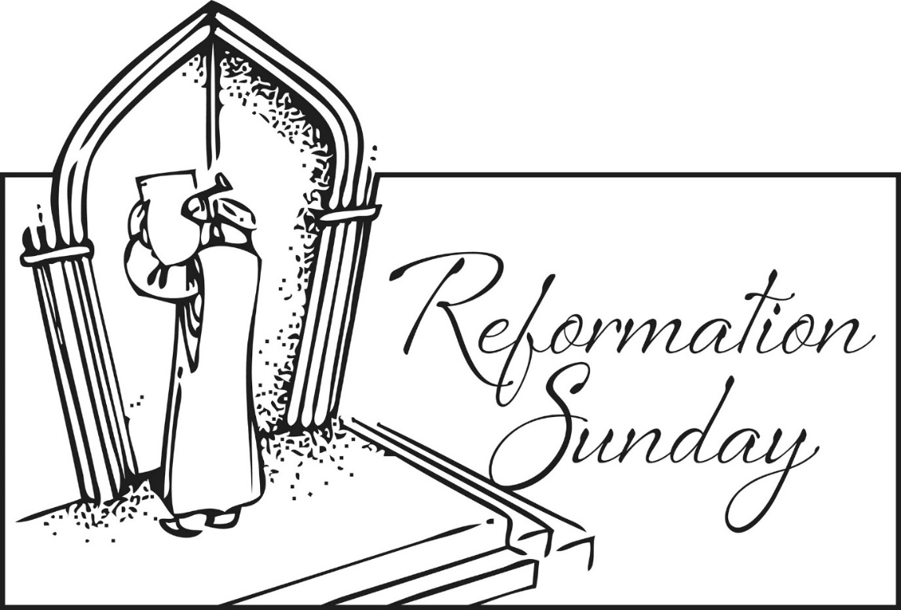

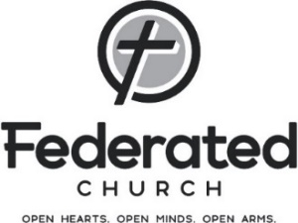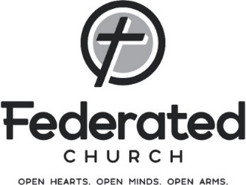

**‘What We Believe’**

**as Voiced in the**

**Apostle’s Creed**

**October 29, 2023**

**The Greeting & Passing the Peace**

The grace of the Lord Jesus Christ, the love of God, and the fellowship of the Holy Spirit be with you all. **And also with you.**

As we are forgiven and reconciled to God through Christ Jesus, let us be reconciled to each other.

The peace of the Lord be always with you. **And always with you.**

**Hymn #385** *All People That on Earth Do Dwell*

**Call to Worship**

God is our refuge and strength, an ever-present help in trouble.

**Therefore, we will not fear, though the earth give away and the mountains fall into the heart of the sea, though its waters roar and foam and the mountains quake with their surging.**

There is a river whose streams make glad the city of God, the holy place where the Most High dwells. God is within her, she will not fall; God will help her at break of day. Nations are in uproar, kingdoms fall; he lifts his voice, the earth melts.

**The LORD Almighty is with us; the God of Jacob is our fortress.**

Come and see what the LORD has done, the desolations he has brought on the earth. He makes wars cease to the end of the earth. He breaks the bow and shatters the spear; he burns the shields with fire. He says, “Be still, and know that I am God; I will be exalted among the nations, I will be exalted in the earth.” **The LORD Almighty is with us; the God of Jacob is our fortress. Psalm 46**

**Hymn #275** *A Mighty Fortress Is Our God*

**God the Father**

Salvation comes to us by grace alone, through faith alone, in Christ alone. In the Apostles’ Creed, we join with Christians of all times and places to express this faith. We come together in heart and mind and purpose, using the words of Scripture and of the Apostle’s Creed to say what we believe.