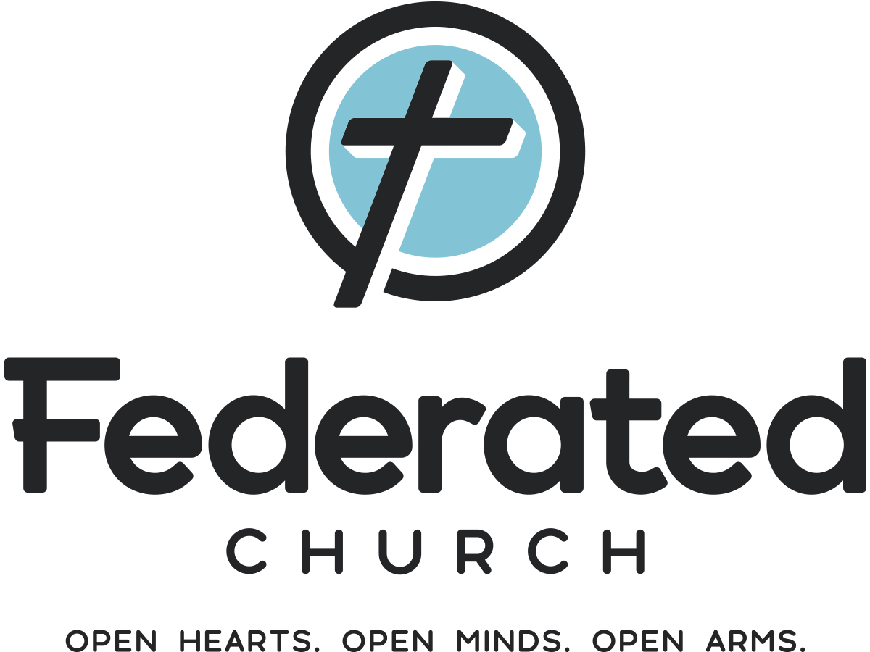
224 N. Union Avenue, Fergus Falls, Minnesota, 56537

(218) 739-3227  church@federatedff.org

The Reverend Douglas Dent

Application for Employment
Director of Pastoral Care

Name (First) (Middle) (Last) DOB

Address

Email Driver’s License Number Religious Affiliation

Home Phone Cell Phone Date available to begin

Please submit a résumé noting your educational background, employment history, wage history, and other training, licensures or qualifications that may be appropriate. Please provide at least three references that we may contact.

I understand that this is an application for a position only and does not imply any promises of employment on behalf of the Federated Church.

I understand that employment is subject to a favorable report from the MN Bureau of Criminal Apprehension.

I hereby declare that all of the information on this Employment Application Form (and any other documentation submitted as part of the application process) is accurate and true; and I understand that any falsehood or omission on my part may be grounds for future dismissal from the position or withdrawal of an offer of employment.

Signature Date

