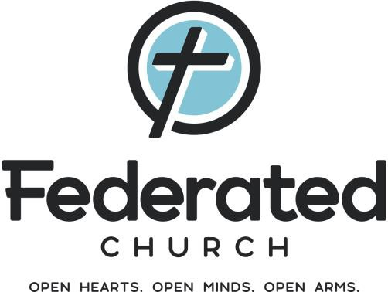

# Federated Church, Fergus Falls, MN Requests for Funding from Endowment Fund

Disbursements from the Federated Church Endowment are distributed according to guidelines set out in The Endowment Plan and its appendices. Those guidelines are included, below, for your easy reference. Request for funding from the Endowment *must* meet the goals. Please prayerfully consider these goals and selection criteria before submitting your request.

*Requests for funding should be submitted to the Endowment Committee by October 31st each year but may be received and considered at any time.*

Who may request funding?

The Board of Deacons and Elders; committees of the Federated Church; a special Church committee or task force; ministerial or professional staff members; or a group, agency or charity not affiliated with the Church, if sponsored by any of the above.

Statement of Purpose

The members of Federated Church (hereafter “Federated”) honor the gifts and bequests of those who have gone before us by dedicating the spirit and income of the Endowment to the mission and needs of our church, our community, and our world.

Goals

Distributions from the Endowment shall be used to advance the presence and mission of the church in the lives of people locally, nationally, and globally.

To that end, distributions shall be designated for major, long-term, recurring and/or special projects and ministries:

* within our local church and congregation, including the maintenance, repair, renovation, and new construction of facilities; and the acquisition of special equipment and supplies;
* within our local and regional community, including support for the victims of natural disasters, relief for the poor and destitute, and assistance to ecumenical needs and projects; and
* within the global community, with special emphasis on responding to poverty, neglect, abuse, homelessness, illness, malnutrition, exploitation, and crime; education, including Christian education; recognizing and nurturing gifts and attributes; and nurturing the faith.

Selection Criteria

In reviewing and approving requests, the Endowment Committee and the Deacons and Elders shall use the following criteria:

* The request must meet the goals set forth above.
* In any given year, distributions will be made to no more than six distinct ministries, at least two-thirds of which shall serve the local community.
* Preference shall be given to proposals that seek to involve the congregation in the ministry. The committee and the Deacons and Elders may request assistance from a council, committee, or task force to enlist congregational support for a ministry.
* Although proposals of all sizes will be considered and/or approved, preference will be given to proposals that are anticipated to have significant impact.
* Only single year proposals will be considered.
* Requests for renewal of support beyond the original proposal may be considered. Groups will need to reapply each year.
* The Endowment Committee and the Deacons & Elders shall encourage the approval of at least one new ministry in each three-year period.



# Federated Church, Fergus Falls, MN Request for Funding from Endowment Distributions

Applicant:

Contact Person:

Church Sponsor or Committee:

Address:

Phone: Email:

Amount requested:

Would you accept a lesser amount? ◻ Yes ◻ No If yes, what amount: $

Is this a new request or a renewal request? ◻ New ◻ Renewal Date funding is needed?

Will the requested funds be matched or supplemented with matching funds or contributions, in-kind contributions, or service hours contributed by the congregation or members of the organization? ◻ Yes ◻ No

If yes, please specify:

Please attach a statement of purpose which includes a discussion of how your request meets all the goals and selection criteria set forth in The Endowment Plan.

Are you requesting a meeting with the Endowment Committee and/or the Deacons & Elders before your request is considered? ◻ Yes ◻ No

If yes, how much time is needed? minutes. Please attach other materials which support your request.

Documents Required:

+ Cover letter

+ Proposed Budget

+ Plan to raise additional funds

Documents Desired:

+ Information about your parent/sponsoring organization

+ Annual reports

+ Promotional Materials

Signature of Applicant:

Date of application:

Submit this form, statement of purpose and supporting documents, to the Federated Church office by October 31, 2024.

Federated Church Endowment Committee 224 N. Union Avenue, Fergus Falls, MN 56537